According to the regulations of the Iranian Ministry of Foreign Affairs, a visa is issued for a maximum stay of 30 days with option of Extensions in Iran. The visa remains valid for a period of 3 months from the date of issue. The following items is required by Iranian Ministry of foreign affairs.
Please provide us with the following documents:
- Digital image of your passport

Your digital image of your passport must be:
- In color
- In JPEG (.jpg or .jpeg) file format
- Equal to or less than 500 kB (kilobytes) in file size (less than 10 kB is not accepted)
- Only the first page. full-length images are not acceptable.
- In a rectangular aspect ratio ( height must be less than width )
- Be sized in 800(minimum-width) x 600(minimum-height) pixels
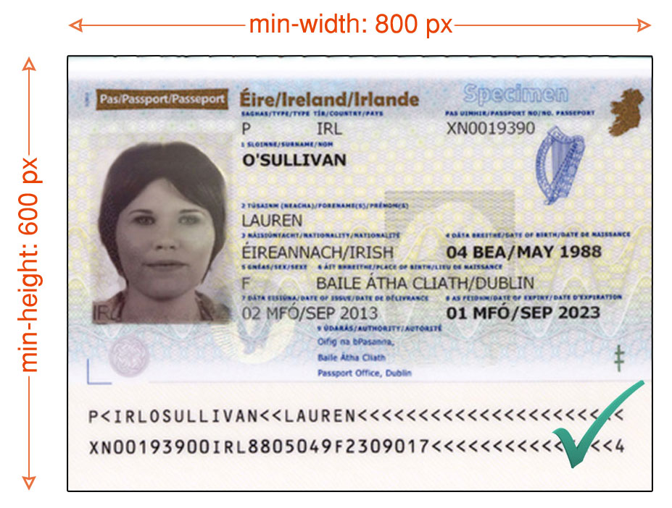
- Sharp without any visible pixels
- properly exposed (too dark or light is not acceptable)
- In a right position.
- Clear and all characters must be readable.

- A personal photo of you

Your personal photos must be:
- In color
- In JPEG (.jpg or .jpeg) file format
- Equal to or less than 500 kB (kilobytes) in file size (less than 10 kB is not accepted)
- In a rectangular aspect ratio (height must be greater than width)
- Be sized in 400(minimum-width) x 600(minimum-height) pixels, with about 70-80% part of the photo must be filled by the applicant’s face
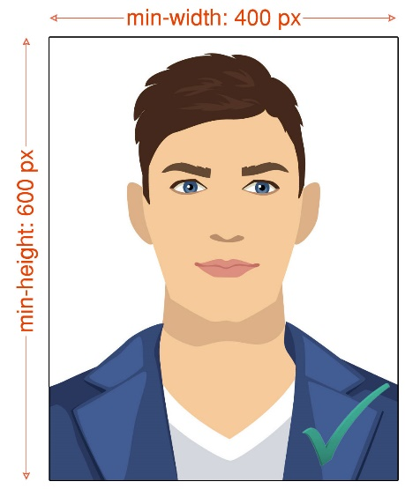

- Resume or curriculum Vitae
- Visa Form which is to be completed by the guest himself/herself.
After providing us with the requested information, ISCO will be able apply for visa and as soon as issuing the visa grant notice by the Iranian Ministry of Foreign Affairs, you will be noticed by Email by your host.

Iran Visa Application Form
مشخصات |  | فارسی (Persian) | انگلیسی (English)
نام | Name
نام خانوادگی | Surname
نام پدر | Father's Name
جنسیت | Sex
تابعیت فعلی | Nationality
تابعیت قبلی | Former Nationality
محل تولد | Place Of Birth
تاریخ تولد | Date Of Birth
وضعیت تأهل | Marital Status
شغل | Occupation
سمت و تخصص | Position and Specialization
نام موسسه /شرکت | Company
موضوع فعالیت | Field of Activity
شماره گذرنامه | Passport No
نوع گذرنامه | Passport Type
تاریخ صدور گذرنامه | Date Of Issue
تاریخ انقضا گذرنامه | Passport Expiry Date
شماره تلفن ثابت | Phone Number
شماره تلفن همراه | Cellphone Number
نشانی ایمیل | Email Address
نشانی محل سکونت | Residence Address
کدپستی محل سکونت | Postal Code (Optional)
شماره تلفن میزبان در ایران | Iranian Host Phone Number
نشانی محل اقامت در ایران | Address in Iran
مدت اقامت در ایران | Duration of Stay in Iran
نزديكترين سفارت / كنسولگري ايران به محل اقامت | Nearest Iranian Embassy to your address
محل اخذ روادید | Visa Issuance Place
دلیل سفر به ایران | The reason for traveling to Iran
تاریخ تقریبی ورود به ایران | Estimated arrival date to Iran
تاریخ تقریبی خروج از ایران | Estimated departure date form Iran

